Let’s Talk Climate campaign – Parish and Town Councils Communications Pack

Thank you for helping is to create awareness of Let’s Talk Climate. We’re grateful for your support in maximising the reach of these messages through your own channels and platforms.
In this pack you will find an overview of the conversation campaign, FAQs and assets to help promote the campaign.

Let’s Talk Climate began on Monday 13th February. At the time of writing, the Let's Talk Transport Consultation (about the Local Transport plan for York and North Yorkshire) is also planned to take place sometime in the next few months.

Background

In July 2022, a Climate Emergency was announced. The draft climate strategy sets out how the new North Yorkshire Council is proposing to respond to this emergency.

To help inform the strategy Let’s Talk Climate will launch on Monday 13 February. The consultation will ask residents for their views on whether the council is doing enough to meet its climate change target. The results will be fed back into the strategy which will form the Climate Change plans for the new council.

The Let’s Talk campaign approach was used successfully to engage residents on Local, Money and Devolution in Autumn 2022. This phase 1 campaign saw:
- 23,636 people visit the online survey platform
- 8,302 surveys were completed
- 2,839 people subscribed to stay in touch about future consultations

Let’s Talk Climate will use the learnings from this first engagement and benefit from the large number of people who subscribed to stay informed.

Let’s Talk Climate
We want to understand how the public are feeling, gather intelligence and use that to the final Climate Change Strategy for the new authority. We will ask for their views on the current draft plan.

What do we want to achieve?
- understand what residents and businesses know about Climate Change
- understand if residents and businesses agree with the draft Climate Change Strategy
- engage with potential community groups
- engage with a diverse demographic
- provide a representative view of the population of North Yorkshire
- raise awareness of the work the council does towards carbon reduction 2000 responses

How?
The campaign will take the conversation to the places people go. As well as face-to-face events, we aim to reach a broad and diverse audience, with a focus on young people under 25. All feedback will inform and shape climate plans for the new council.

Learnings from Let’s Talk phase 1 show that our own corporate county, district, and borough channels provide the best conversion rates, therefore our campaign will focus on these, as well as using existing partners and our staff to advocate the campaign helping us to maximise reach. We will, also, engage the thousands of subscribers to Commonplace – the digital platform for Let’s Talk.

Let’s Talk Climate will run alongside Let’s Talk Transport (engagement around the new council’s transport strategy) for four weeks. This will give us the opportunity to provide a joined-up approach to target specific audiences such as youth and seldom heard groups, as well as combining resources at events. We are working with Harrogate Youth Council which represent a range of ages from 11 – 22 to co-produce questions for the Climate & Transport Youth Survey.

Key messages
- Mitigation: How do we stop/slow down climate change?
- Adaptation: How do we prepare for the changing climate?
- Helping Nature to Thrive: What more can we do to support nature?

Teams event – Parish and Town
You are invited to a Microsoft Teams event on Monday 13th February at 6.30pm. This is an open meeting for Parish and Town Councils and elected Members which will go through the consultation and how to respond to it. If you would like to join this event you can click the link below:
Click here to join the meeting
Meeting ID: 379 701 403 586
Passcode: JzJnLY
Parish Council Drop Ins
We are running drop-in sessions for Parish Councils, in partnership with the Parish Charter events across the county during February where you can discuss anything relating to the new North Yorkshire Council including the Climate Change Consultation – please see dates below:

9th February 2023
10-1 pm

Hambleton District Council Civic Centre, Stone Cross, Rotary Way, Northallerton, North Yorkshire, DL6 2UU
Directions: https://www.hambleton.gov.uk/council/location

10th February 2023
2-5 pm
Ryedale District Council
Ryedale House, Old Malton Road, Malton, North Yorkshire, YO17 7HH
Directions: https://www.ryedale.gov.uk/about-the-council/contact-the-council/

13th February 2023
11:30 – 2:30 pm
Craven District Council
Belle Vue Square, 1 Broughton Road, Skipton, North Yorkshire, BD23 1FG
Directions: https://www.cravendc.gov.uk/contact-craven-district-council/visiting-craven-district-council/

14th February 2023
2 – 5 pm
Scarborough Borough Council
Town Hall, Scarborough, North Yorkshire, YO11 2HG

Directions: https://www.scarborough.gov.uk/home/contact-us-and-opening-hours

17th February 2023
2 – 5 pm
Harrogate Borough Council
Civic Centre, St Lukes Avenue, Harrogate , HG1 2AE

Directions: https://www.harrogate.gov.uk/contacting-us/contact-us

23rd February 2023
2 – 5 pm
Richmondshire District Council
Mercury House, Station Road, Richmond, North Yorkshire, DL10 4JX
Directions: https://www.richmondshire.gov.uk/about-the-council/contact-us/mercury-house-richmond/

27th February 2023
2 – 5 pm
Selby District Council
Civic Centre, Doncaster Road, Selby, North Yorkshire, YO8 9FT

Directions: https://www.selby.gov.uk/contact-us

Visit https://www.northyorks.gov.uk/parish-charter-consultation for more information on the consultation and drop-in sessions.

The Campaign – Let’s Talk Climate
The communications pack will launch on Monday 13th February and run until the middle of April 2023. At the time of writing, the Let's Talk Transport Consultation (about the Local Transport plan for York and North Yorkshire) is also planned to take place sometime in the next few months.
The campaign will aim to:
- Create awareness of the Climate Consultation Survey
- Ask residents whether they think the councils plan is correct and if we are doing enough and feedback their view- which then forms the final Climate Change Strategy
- Inform audiences about Climate Change and the work towards Carbon Net Zero in North Yorkshire
If you have any questions about the campaign please contact:
Charley Christopher, Marketing and Customer Communications Officer. E: charley.christopher@northyorks.gov.uk or email letstalk@northyorks.gov.uk
Copy for websites/newsletters
- For use from 13th February
- Survey Link https://letstalkny.commonplace.is/en-GB/proposals/climate
- QR codes can be supplied for printed material - – please email Charley.christopher@northyorks.gov.uk

Email / newsletter / website copy

- For use from 13th February
- We want to remind residents about the Climate Change Survey

In July 2022 a Climate Emergency was announced for North Yorkshire. With existing plans in place to reach Net Zero by 2030, Climate Change officers from across the county created a draft Climate Change Strategy to achieve this goal. And be the first Carbon Negative region by 2040.
During the first phase of Let’s Talk, responses collected show that Climate Change was ranked as a top 3 priority by:
34% of people in the Let’s Talk Local Survey
41% of people in the Let’s Talk Money Survey
Let’s Talk Climate will gather your views and feedback on the draft Climate Change Strategy. By answering the survey questions, which focus on: slowing down and adapting to climate change as well as helping nature to thrive, the information you give will be fed back forming the final Climate Change Strategy for the new authority – North Yorkshire Council.
You will be able to share your views online using a safe and easy-to-use tool called Commonplace which we used on our previous Let’s Talk engagements. Our libraries are hubs where you can go and find out more about the Climate Change Strategy, with a hard copy of the draft strategy and fill in a paper survey if you wish.

Events will be organised, alongside our Transport consultation, giving you the opportunity to talk to members of the Climate team about whether you think the council is doing enough to meet our Net Zero target. Further information will be available in the coming weeks.

Fill in the Climate Change survey here: https://letstalkny.commonplace.is/en-GB/proposals/climate

WhatsApp messages
- For use from 13th February

You may be a member of a local neighbourhood WhatsApp group, or perhaps just want to encourage your family and friends to take part in Let’s Talk. Please see below suggested copy:
- Climate Change – what do YOU think the new North Yorkshire Council should be doing? We want your views to feed back into the Climate Change Strategy for the new council which launches 1 April 2023 - https://letstalkny.commonplace.is/en-GB/proposals/climate

- The new North Yorkshire Council launches on 1 April 2023 and is asking for your thoughts on Climate Change and what it can do to slow it, adapt to it, and help nature to thrive. Share your views online at https://letstalkny.commonplace.is/en-GB/proposals/climate

If you have any questions, or would like to be sent our campaign toolkit, please email letstalk@northyorks.gov.uk or Charley.christopher@northyorks.gov.uk

Appendix
Social media assets
If you have social media accounts for your parish council, below you will find a series of messages you may wish to post to inform residents about Let’s Talk Climate. We will be sharing information about Let’s Talk Climate across our social media accounts (County Council and the District and Boroughs) which you may wish to share.
- For use from 13th February
- We want to create awareness that the Climate Change Strategy needs input from residents to inform the final strategy for the new council.
- You may wish to use the hashtag #LetsTalkClimate
Asset | Content
Facebook and Twitter  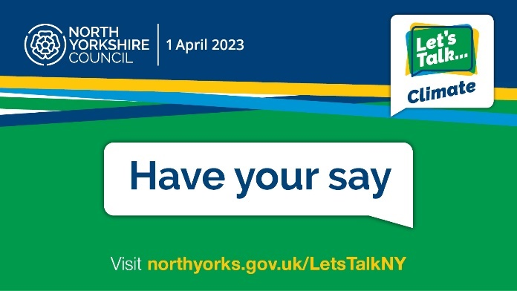 | We've launched Let’s Talk Climate, and we want everybody in North Yorkshire to get involved and voice their ideas, what works and what we can do to improve our climate. Tell us your views here: https://letstalkny.commonplace.is/en-GB/proposals/climate  Twitter version:  We've launched Let’s Talk Climate, and we want everybody in North Yorkshire to get involved and voice their ideas, what works and what we can do to improve our climate. Tell us your views here: https://letstalkny.commonplace.is/en-GB/proposals/climate  #LetsTalkClimate
Instagram  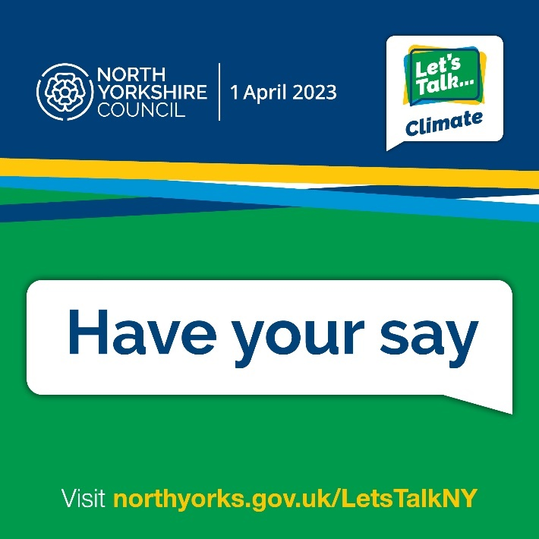 | We've launched Let’s Talk Climate, and we want everybody in North Yorkshire to get involved and voice their ideas, what works and what we can do to improve our climate. Tell us your views here: (If you have the facility – Click through the link in our Bio) https://letstalkny.commonplace.is/en-GB/proposals/climate  #LetsTalkClimate
Facebook/Twitter 2:  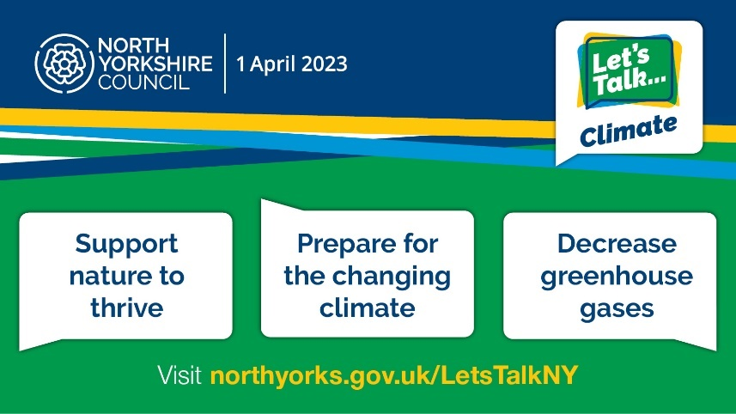 | Have you taken part in Let’s Talk Climate yet?  Teams from the council are holding these conversations at events across the county this month and next, and they want to hear from you.  Share your views online at :https://letstalkny.commonplace.is/en-GB/proposals/climate  #LetsTalkClimate  Twitter version:  Have you taken part in Let’s Talk Climate yet?  Find out how you can tell us your views online and in person at:  https://www.northyorks.gov.uk/LetsTalkNY #LetsTalkClimate
Instagram  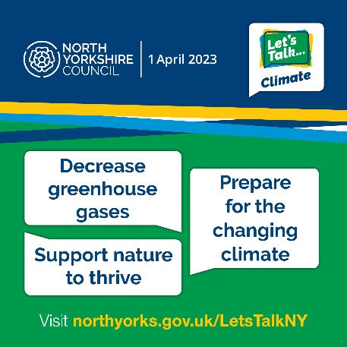 | Have you taken part in Let’s Talk Climate yet?  Teams from the council are holding these conversations at events across the county this month and next, and they want to hear from you.  Find out where your local conversations are taking place, or share your views online at https://www.northyorks.gov.uk/LetsTalkNY.  #LetsTalkClimate
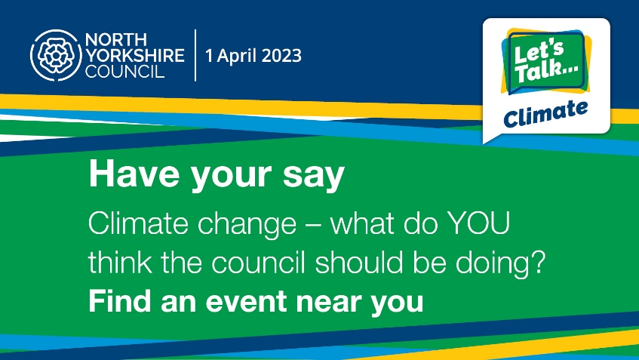 | Twitter version – use for events- such as Parish and Town drop in sessions  North Yorkshire Council will be at <venue> on <date> between <time> to find out what local services matter most to you & how they can support you. Find your local conversation at https://www.northyorks.gov.uk/LetsTalkNY #LetsTalkClimate  See a list of parish drop in sessions above which you can use to tailor these posts. This tweet could be repeated throughout the campaign with details of different local events.
Facebook/Twitter 3:  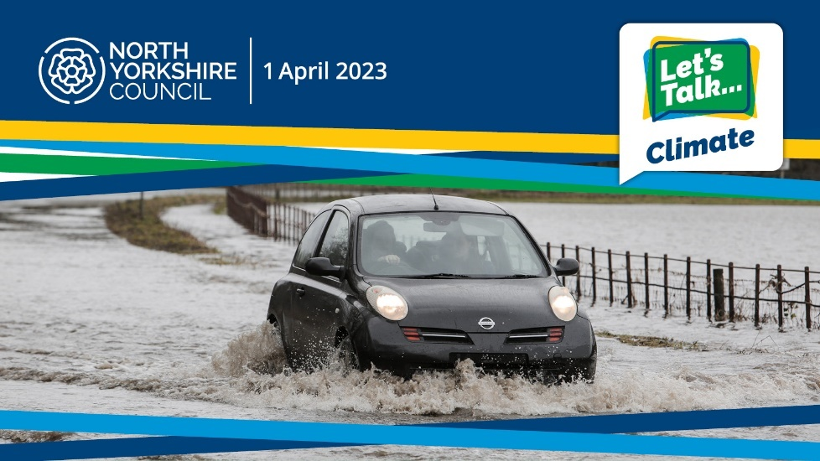 | 🌍We've launched Let’s Talk Climate, and we want everybody in North Yorkshire to get involved. Please have your say - tell us what is happening near you, what works, what doesn’t and what we can do moving forward to achieve Net Zero as a county, by 2030 https://letstalkny.commonplace.is/en-GB/proposals/climate  Twitter version:  🌍We've launched Let’s Talk Climate, and we want everybody in North Yorkshire to get involved. Please have your say: https://letstalkny.commonplace.is/en-GB/proposals/climate  #LetsTalkClimate
Instagram 3:  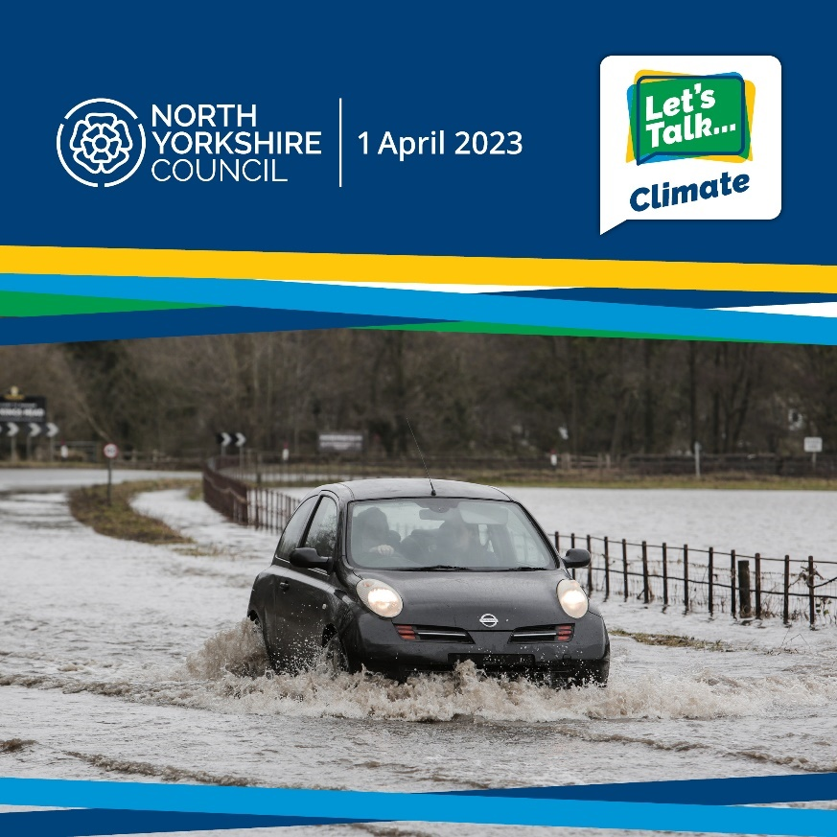 | 🌍We've launched Let’s Talk Climate, and we want everybody in North Yorkshire to get involved. Please have your say - tell us what is happening near you, what works, what doesn’t and what we can do moving forward to achieve Net Zero as a county, by 2030 https://letstalkny.commonplace.is/en-GB/proposals/climate  #LetsTalkClimate
Facebook/Twitter 4:  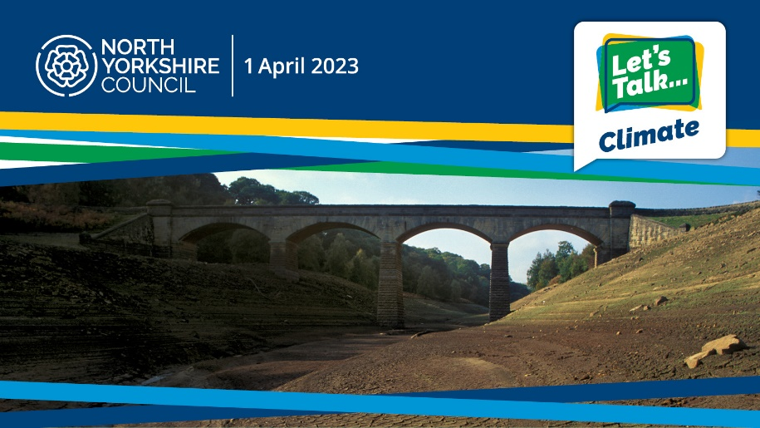 | Have you given us your thoughts on Let’s Talk Climate yet?  If not, you don't have long!  Make sure you have your say 🗣️ by tomorrow (or DATE) at 23:59.  Full details 👉🏽 https://letstalkny.commonplace.is/en-GB/proposals/climate  Twitter Version:  Have you given us your thoughts on Let’s Talk Climate yet?  If not, you don't have long!  Make sure you have your say 🗣️ by (or DATE). Full details 👉🏽 https://letstalkny.commonplace.is/en-GB/proposals/climate  #LetsTalkClimate
Instagram 4:  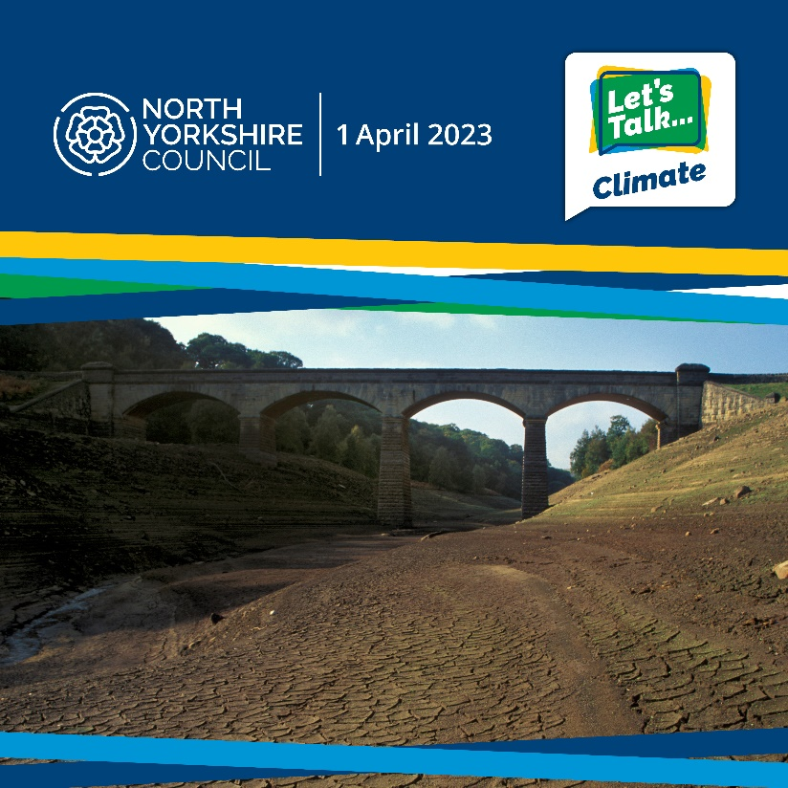 | Have you given us your thoughts on Let’s Talk Climate yet?  If not, you don't have long!  Make sure you have your say 🗣️ by tomorrow (or DATE) at 23:59.  Full details 👉🏽 https://letstalkny.commonplace.is/en-GB/proposals/climate  #LetsTalkClimate

Teams Backgrounds
If you would like to support the campaign by using a background through the teams app, you can use the following:

A4 posters Community – for reference
NB content may vary slightly

These will be distributed to community groups via email/County Hall Print room for them to display in venues and community boards for the duration of the Let’s Talk Campaign – 13th February to the end of April 2023.

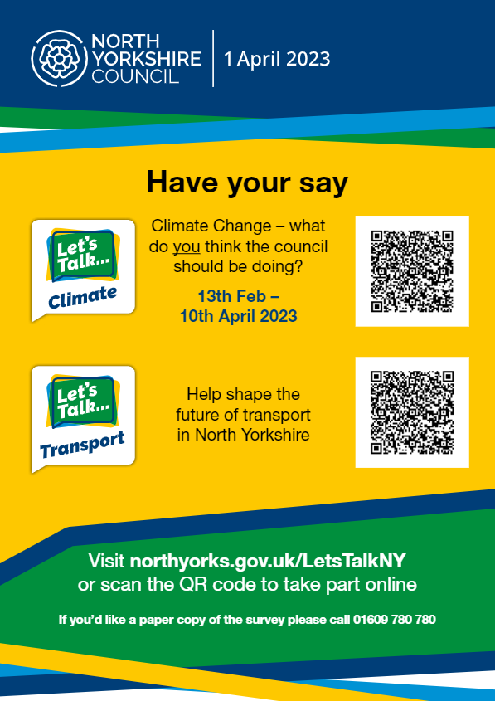

Bookmarks – for reference
NB content may vary slightly

These double-sided bookmarks will be available at libraries and face-to-face events for people to pick up if they don’t have time to complete the survey in person, or to pass along to family/friends. A small quantity will be available in the Supermobile.

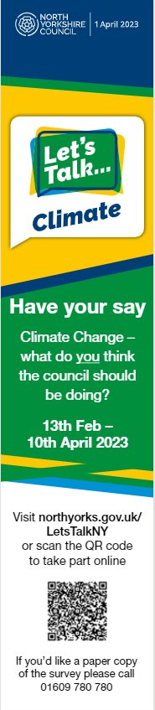

Face-to-face events

A list of face-to-face events will follow

