CRAVENLINK 884 | Ilkley - Addingham - Draughton - Skipton
 | Winter Sundays from 24th October 2021
Ilkley Bus Station | 0910 | 1340 |  | Skipton Rail Station | .. | 1724
Addingham opp. The Fleece | 0917 | 1347 |  | Skipton Bus Station | 1410 | 1730
Draughton opp. Shelter | 0924 | 1354 |  | Draughton Shelter | 1416 | 1736
Skipton Bus Station | .. | 1405 |  | Addingham The Fleece | 1423 | 1743
Skipton Rail Station | 0935 | .. |  | Ilkley Bus Station | 1435 | 1755

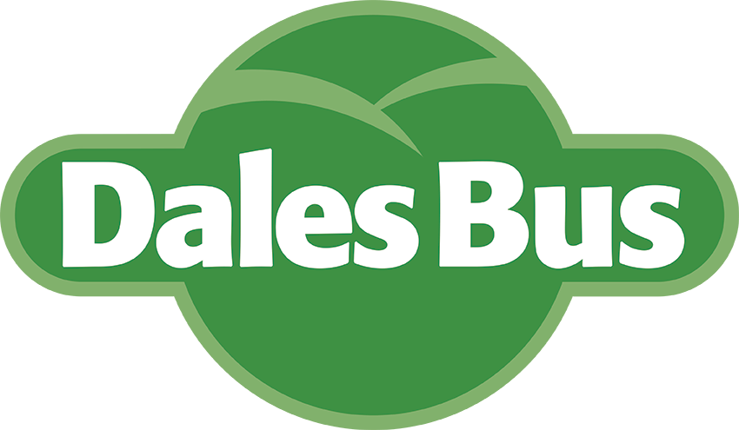
Cravenlink 884 is operated by the Keighley Bus Company 01535 603 284
as part of the DalesBus network.

