Bench on Village Green – Report to Council Meeting on 7 June
Selection of Costed Options
(all benches shown are available in durable hardwood or recycled plastic alternative)
The options suggested below are put forward for consideration as the best of those previously considered.
This takes account of the preferences expressed by villagers in an email consultation carried out in April, and also works on the assumption that all 3 of the existing benches (as inspected with the help of Cllrs Neale and Pighills on 19 May) are worth retaining in their current positions, subject to maintenance by volunteers, as appropriate, such that the new bench will be sited in a new location to the right of the churchyard gate (facing the entrance), matching the one on the left.
Please note – we received grant of £500 from the District Council towards the cost of the new bench. The grant scheme has just re-opened for this year.

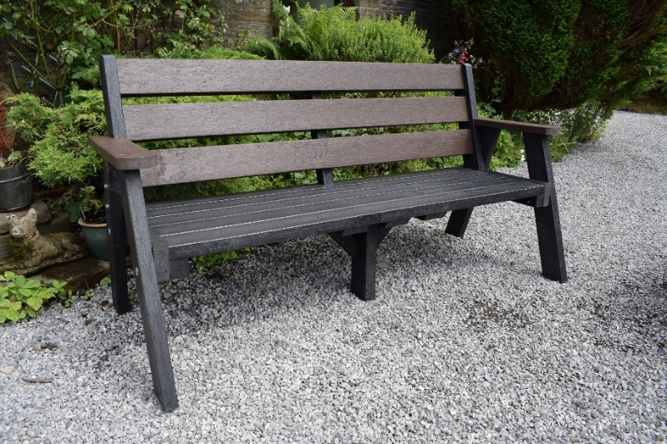
Sloper bench £454 +VAT plus delivery £55
Inscription £90
Second Life Products Wales

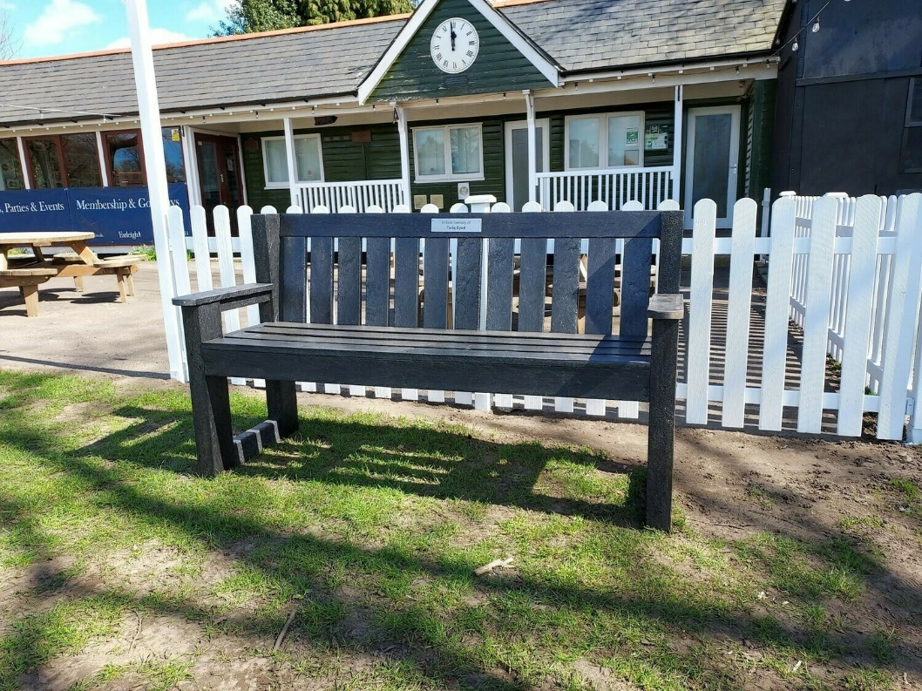
KBS Depot – Sandringham Seat
£450, free delivery
Black recycled plastic, fashioned to replicate hardwood traditional style
Plaques, inscriptions charged extra
Optional fixings and installation on site
Or – Sloper seat – spec as above - £499, black or brown

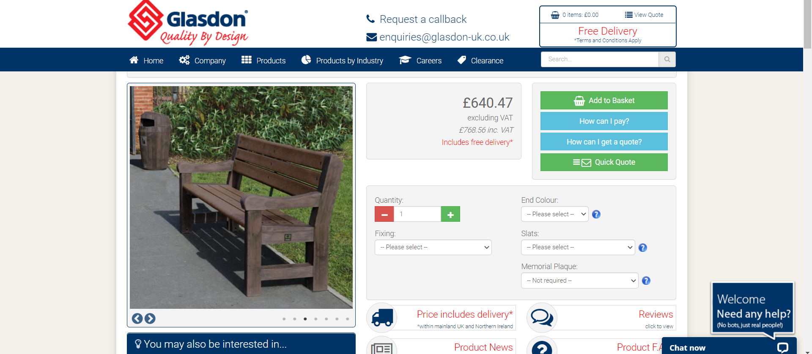

Plus plaque £90

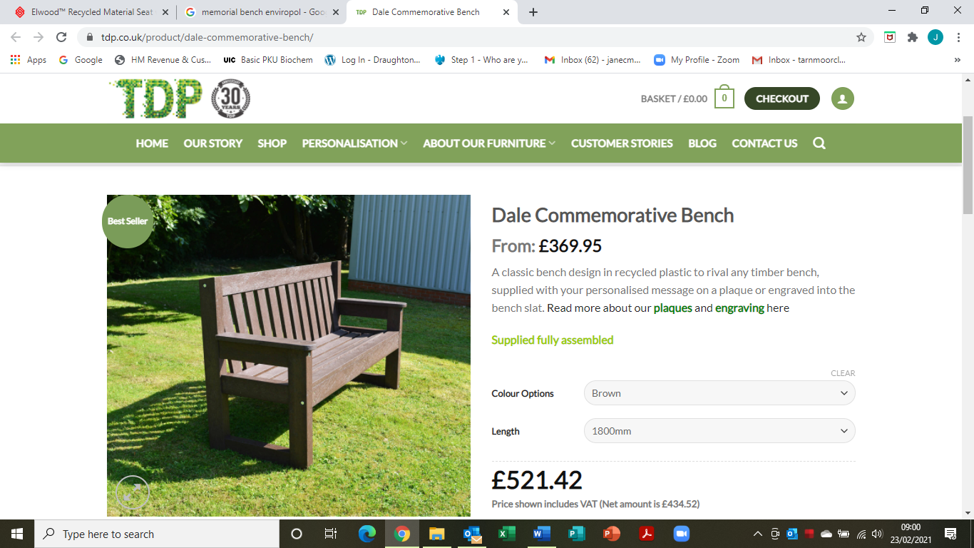

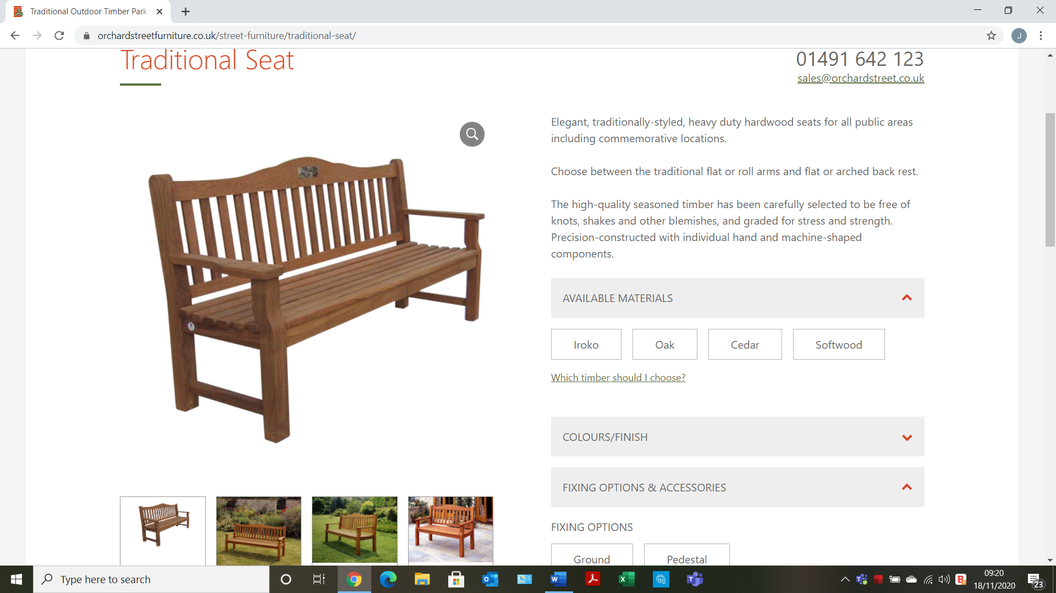
Cost: £450 +VAT Fixings £20 Inscription £5 per letter (20 letters = £100)

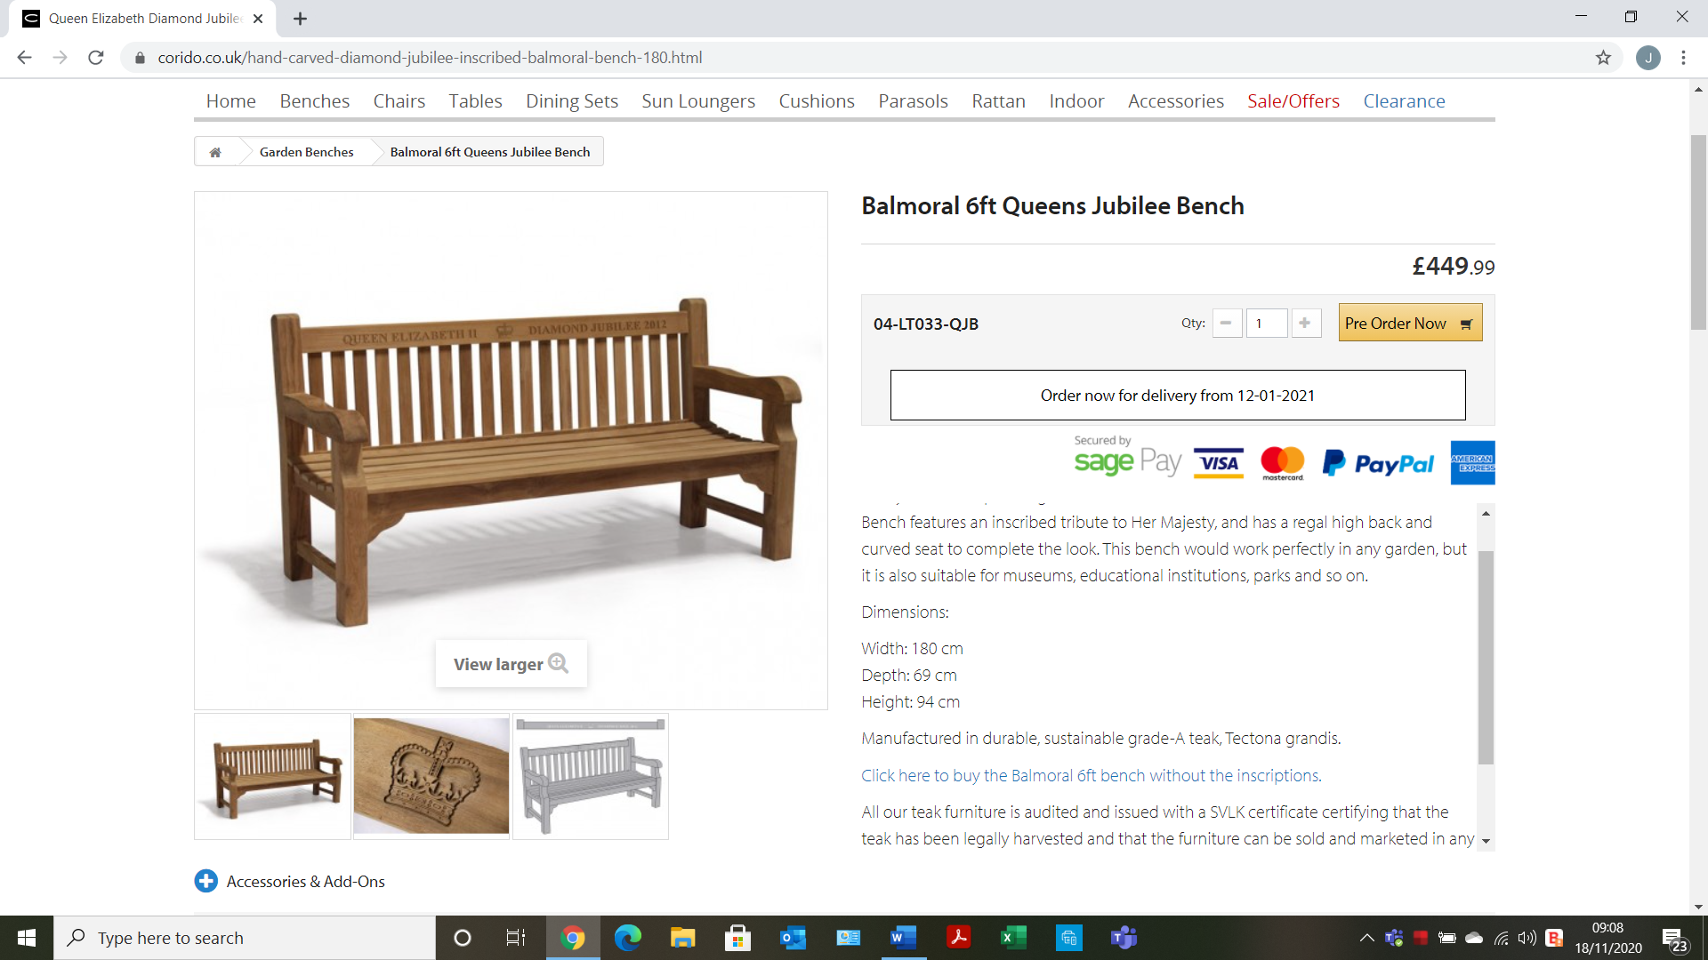
Plus inscription - £75

