Bench on Village Green
Selection of Costed Options for Replacement Product
(all durable hardwood or plastic alternative)

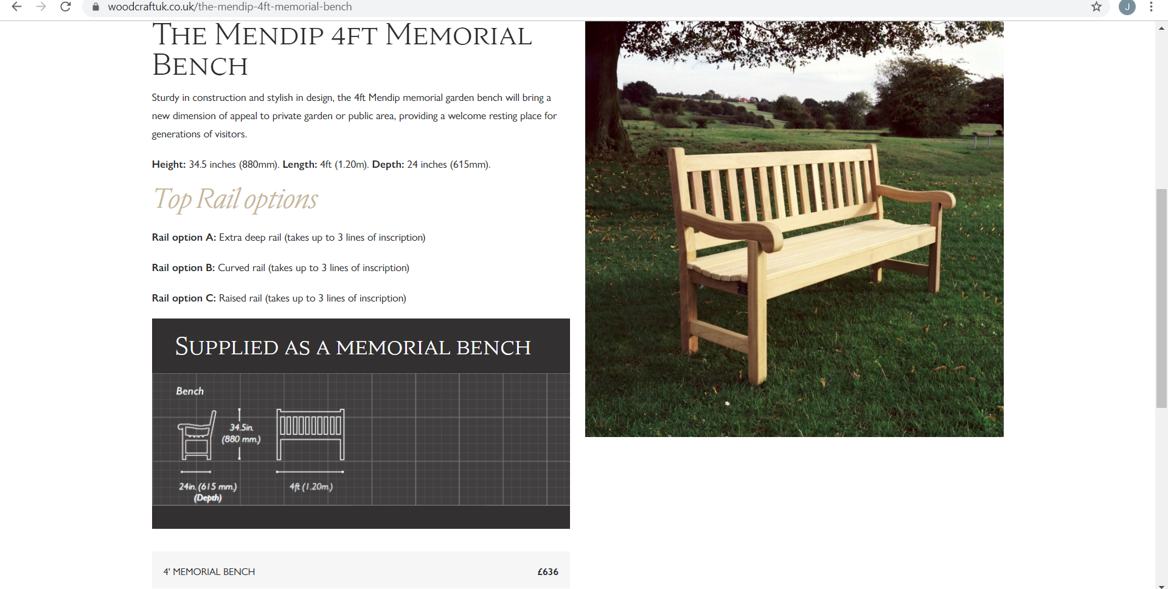
Plus fixings £34 Oiling £46 Inscription: £2.20 per character (20 letters = £44)

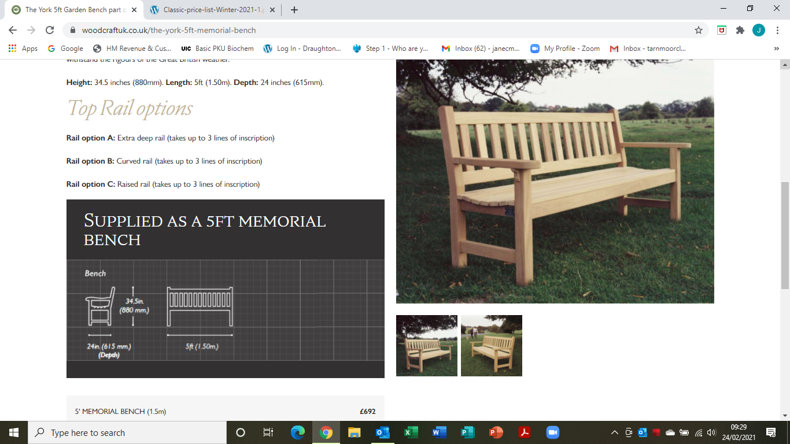
Available in Iroko hardwood

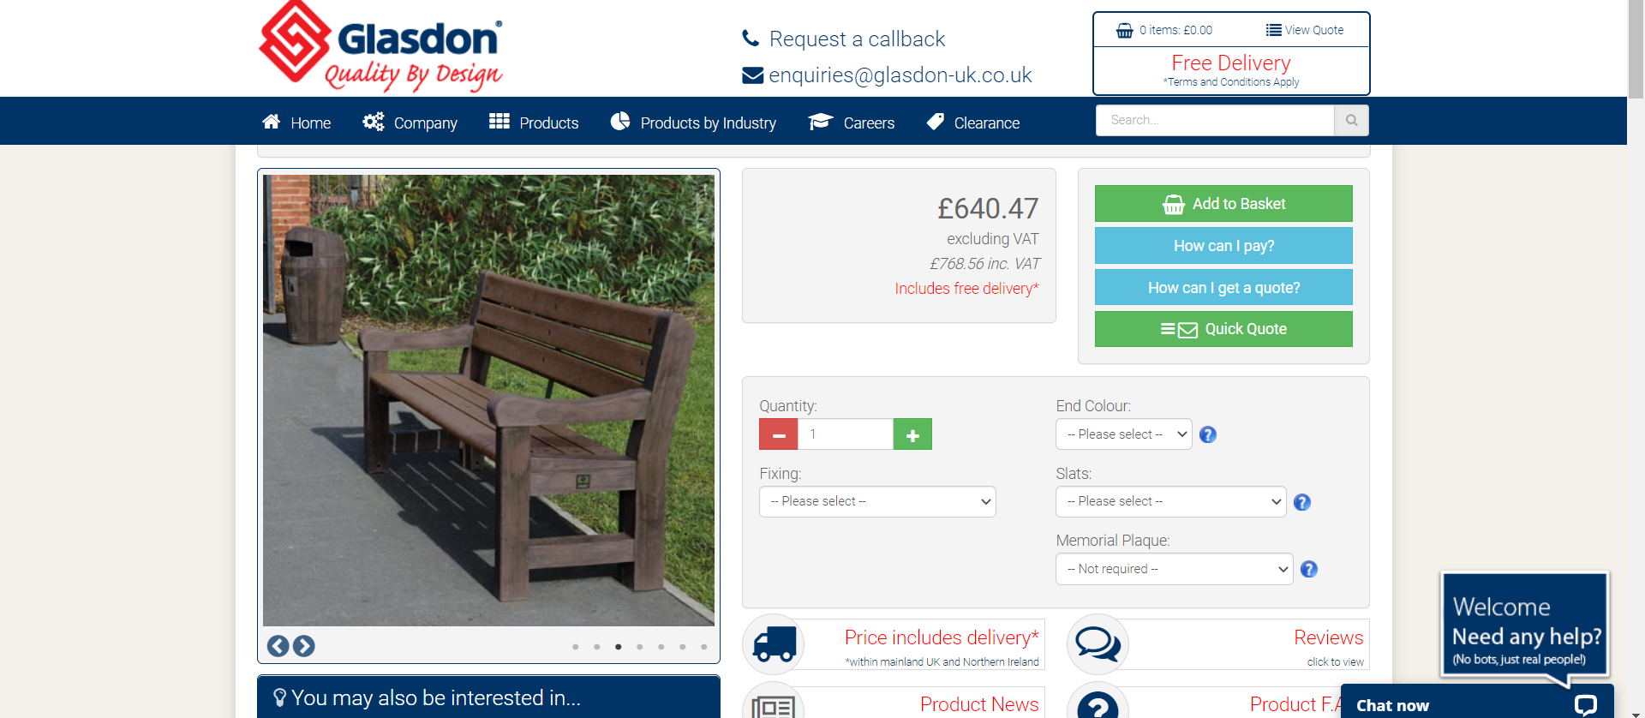

Plus plaque £90

Second Life (Wales) Sloper Bench - £454+VAT, +£55 delivery, +£125 engraving (see email 23/2)

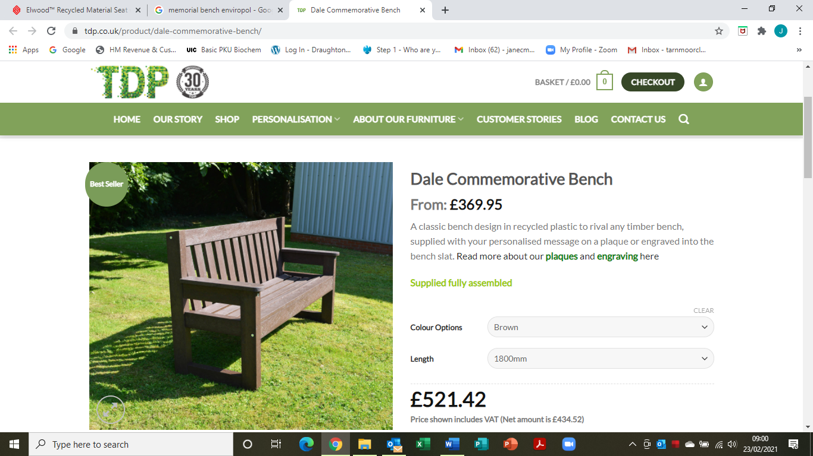

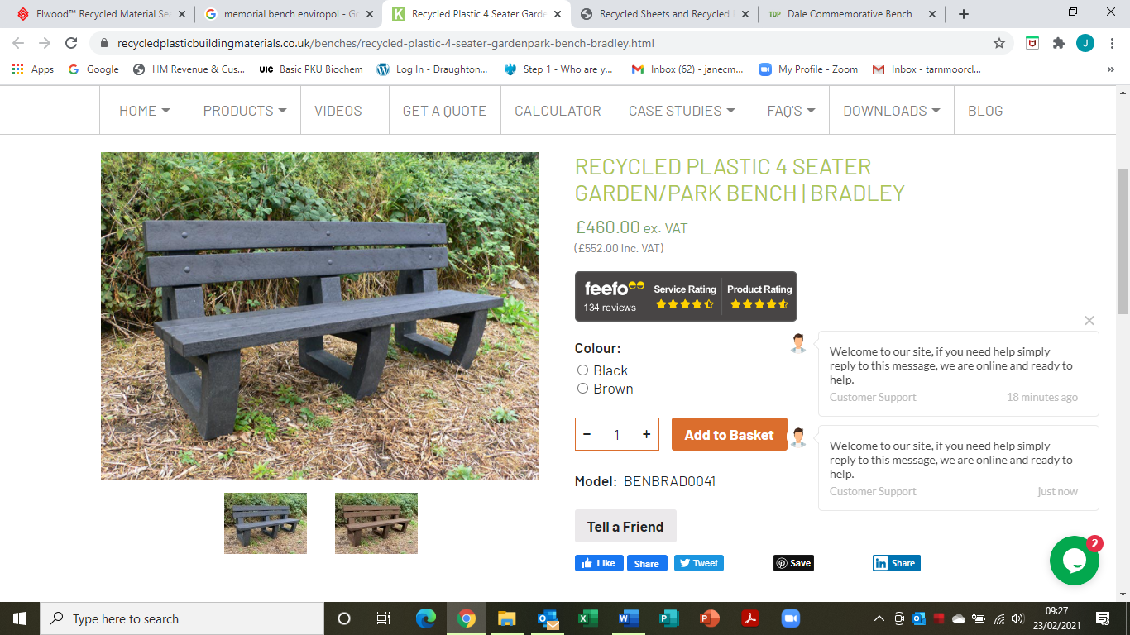
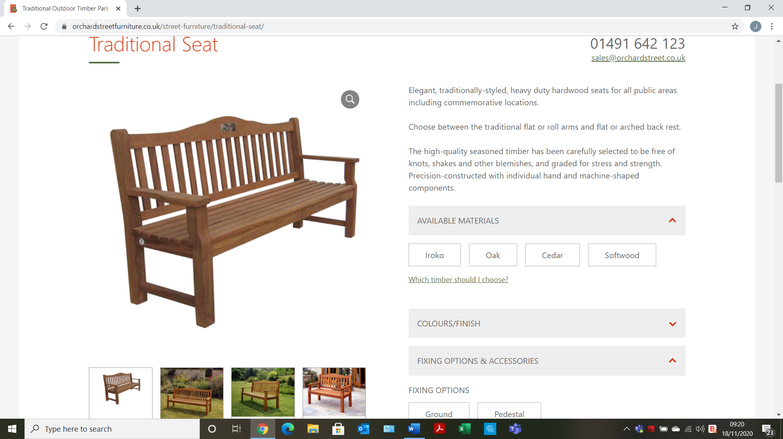
Cost: £450 +VAT Fixings £20 Inscription £5 per letter (20 letters = £100)

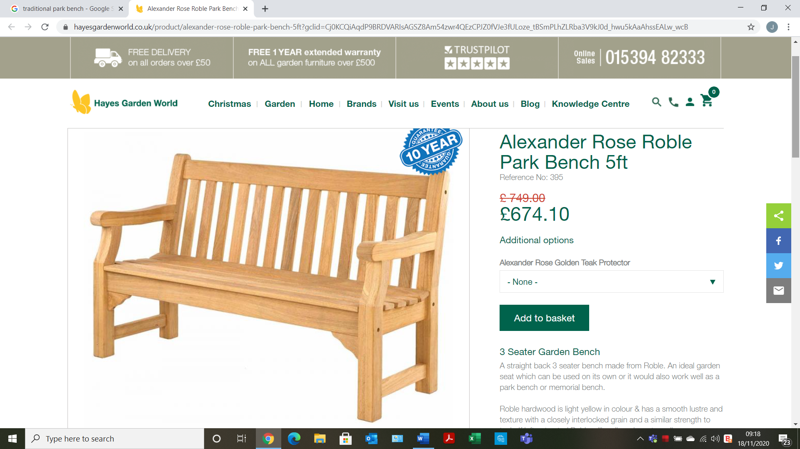
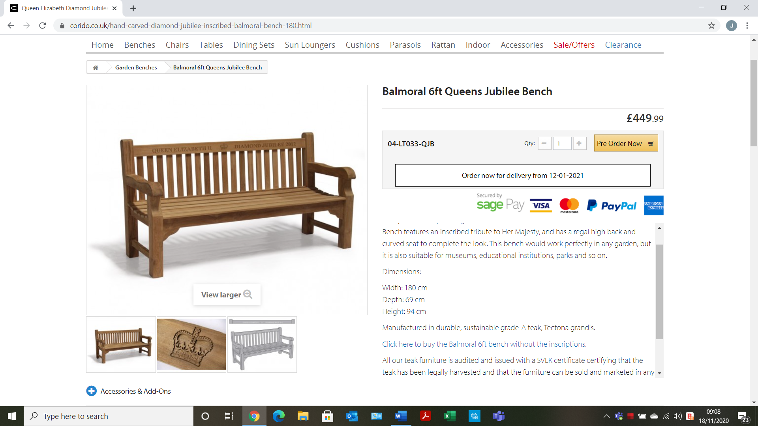
Plus inscription - £75

