KBS Depot
Sandringham seat
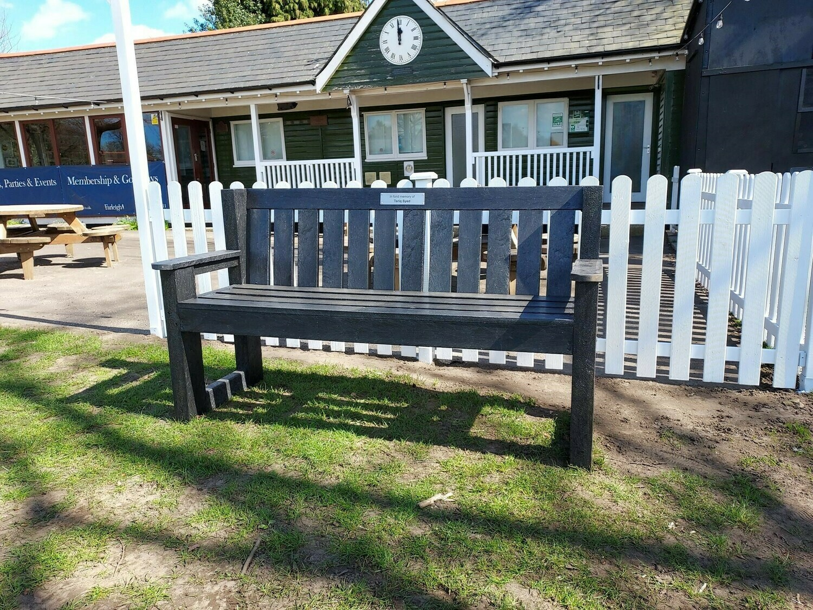
£450, free delivery
Black recycled plastic, fashioned to replicate hardwood traditional style
Plaques, inscriptions charged extra
Optional fixings and installation on site
Or – Sloper seat (below) – spec as above - £499, black or brown
