EUCHARIST AT ST AUGUSTINE’S
SUNDAY 23 AUGUST AT 11 A M
After an uncomfortable period of closure, our church will re-open for public worship with a communion service on Sunday 23 August at 11 a m. The bell will be rung from 10.55 to announce the opening. On that Sunday, the church will not be open for private prayer in the afternoon, and we will review the situation thereafter. Safety issues have been thought through very carefully and the church’s Covid 19 risk assessment is available to view on the website at www.draughton.org.
This is a small church and social distancing will be in place; this means only alternate pews will be in use, and the maximum number of people we can manage will be limited to approximately 16 individuals (the number is not precise, as members of the same household may sit next to each other on the same pew). Stewards will guide you through entering and leaving the building safely and show you where to sit.
When you arrive, please wait outside until invited in by a steward. Please wear a face covering, and if you bring anything with you, such as a bible, please take it away with you. A single-use order of service will be provided, containing everything you need for the service; please do take it away with you after use. You might like to bring your own cushion, as the seat coverings have been removed in the interests of hygiene! The pews will be disinfected after use.
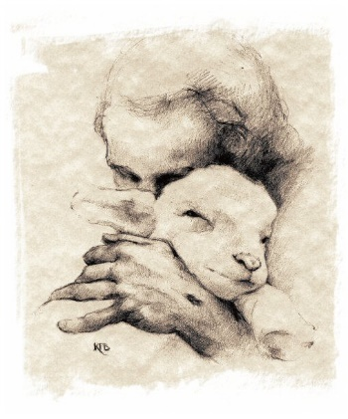
For Communion services, consecrated wafers will be distributed without being handled by the priest or the lay assistant, and only the priest will consume the consecrated wine, on behalf of the congregation. Sadly, current government guidelines preclude congregational singing; we can only hope this will change soon. Meanwhile however, we are delighted that our regular organist, Susan Watkiss, is able to come to play to us during the service.
Please do not come, of course, if you have Covid 19 symptoms. Apart from that, each person will be aware of their own level of risk. If you are hesitant about coming to the service, but would like prayers to be said for you, or indeed for anyone else, anonymously, please contact Isobel on isobel.rathbone@gmail.com or 01756 711118. Please also contact either Isobel or the churchwardens at Holy Trinity Skipton with any other concerns or questions you may have.
Thank you to the team (Jeanne, Pat, Jane, Sarah and James, and Roger) who have worked hard on this.
A prayer on the re-opening of the church, as we look forward to worshipping together again:

God of healing and peace, we give thanks for this our church in which to worship you.
Guide each of us as we enter the holy place, to keep it safe, as we seek protection and safety for all; in the name of him who gave his life for us, our Saviour Jesus Christ. Amen.:

