Councillors are summoned to attend:

THE NEXT MEETING OF THE COUNCIL TO BE HELD ON FRIDAY 18 DECEMBER 2015 IN THE VILLAGE HALL
AT 6.00pm [Please note time]

A G E N D A

- Apologies – to receive apologies and approve reasons for absence
- Disclosure of interests – to receive any declarations of interests not already recorded in the Members’ Register of Interests, and to receive and consider applications (if any) for dispensation pursuant to the Council’s Code of Conduct
- Minutes – to confirm the Minutes of the Meeting held on 18 November 2015 as a true and correct record (attached)
- Matters arising – to receive the Clerk’s report on the following ongoing issues, and to decide further action where necessary: (i)Superfast Broadband; (ii)Local Green Space
- Road Safety – to consider a report and proposals to request a lowering of the speed limit on the A65 (attached)
- Locality Fund – to consider the following proposal for making application to the County Councillor’s Locality Fund:
Defibrillator
- Budget and Precept 2016/17 – to approve the Budget and set the Precept 2016/17 (draft Budget with precept proposals attached)
- Other Financial Matters – (1) to approve the month’s accounts for payment: (i)Clerk’s salary; (ii)Expenses - 214.47; (iii)Village Hall - £30, and (2) to receive a proposal to purchase a hi-vis jacket for the volunteer litter-picker
- Consultations and Correspondence– to note e-newsletters circulated for information, and to consider correspondence received and decide action where necessary:
Update from Citizens Advice Bureau
- Next meeting – to confirm the date: Wednesday 13 January 2016

The Press and Public are invited to attend, but the Public are reminded that they are permitted to take part in any discussions only at the discretion of the Chairman.
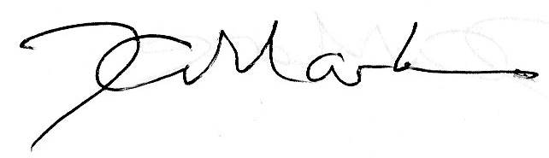
Councillors and Local Electors wishing to have any issues raised at the meeting are asked to notify the Clerk (preferably in writing) in advance of the meeting. At the discretion of the Chairman, any such issues will be included on the Agenda.

